OS Lab 2 (Shell Scripting)
Date: 08 August 2025

1. Write a bash script that takes a user's name as input and uses the echo command to greet the
user with "Hello, [name]!".
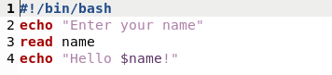

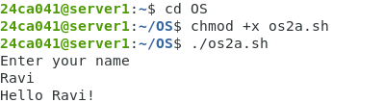

2. Write a Bash script that uses the ls command to list all files and directories in the current
directory.
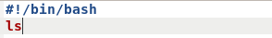

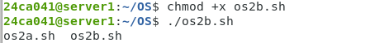

3. Write a Bash script that prompts the user to input a password, and then checks if the
password matches a predefined value. If it does, print "Access granted", otherwise print
"Access denied".
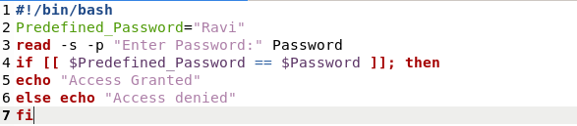
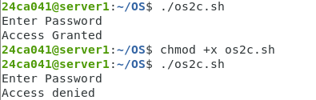

4. Write a Bash script that uses the cat command to concatenate the contents of two text files
("file1.txt" and "file2.txt") and display the result.
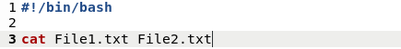

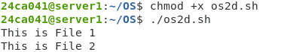

5. Write a Bash script that checks if a given number is even or odd and prints a message
accordingly.
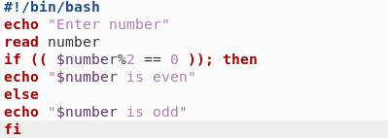

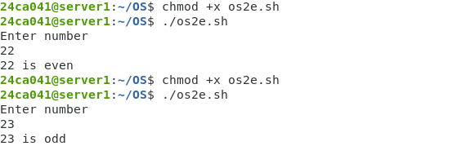
6. Write a Bash script that prompts the user to enter a number and checks if it is positive,
negative, or zero, and prints a message accordingly.
